**DAILY ONLINE ACTIVITIES SUMMARY**

|  |  |  |  |  |  |  |  |  |
| --- | --- | --- | --- | --- | --- | --- | --- | --- |
| **Date:** | **28/05/2020** | | | | | **Name:** | **Albin Francis** | |
| **Sem & Sec** | **8th sem,A** | | | | | **USN:** | **4AL16CS008** | |
| **Online Test Summary** | | | | | | | | |
| **Subject** | | **SMS** | | | | | | |
| **Max. Marks** | | **60** | | **Score** | | | **60** | |
| **Certification Course Summary** | | | | | | | | |
| **Course** | **Getting Started To Hadoop** | | | | | | | |
| **Certificate Provider** | | | **GreatLearning** | | **Duration** | | | **4.5hr** |
| **Coding Challenges** | | | | | | | | |
| **Problem Statement:  Given an array arr[] of size N and an integer K. The task is to find the**  **last remaining element in the array after reducing the array.** | | | | | | | | |
| **Status: Solved** | | | | | | | | |
| **Uploaded the report in Github** | | | | | **Yes** | | | |
| **If yes Repository name** | | | | | **albinfrancis008** | | | |
| **Uploaded the report in slack** | | | | | **Yes** | | | |

Online Test Details: (Attach the snapshot and briefly write the report for the same)

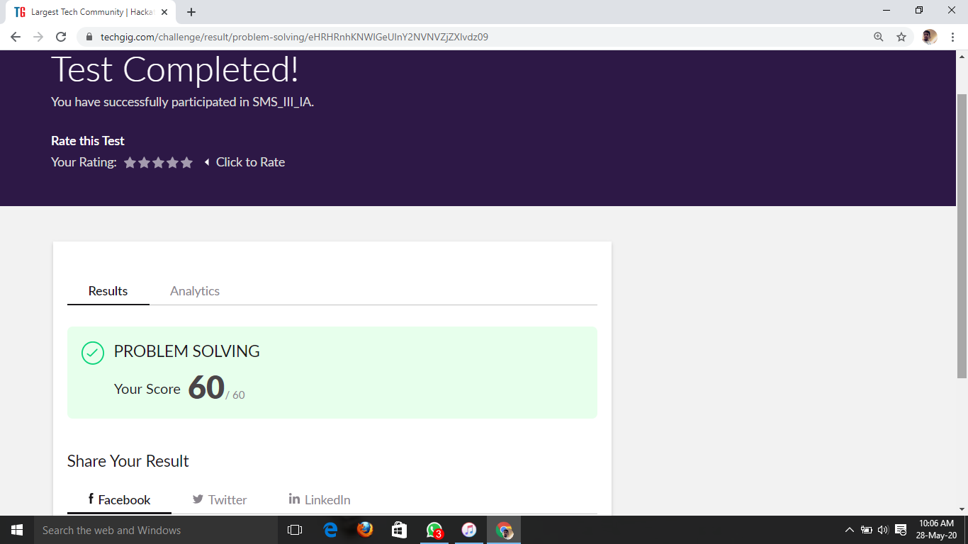

Certification Course Details: (Attach the snapshot and briefly write the report for the same)



ASSESSMENT AND HADOOP INSTALLATION:-

* Assessment
  + - * Hadoop Basic Quiz
      * Hadoop & Map reduce Quiz
* Installation of hadoop in pc
* Installation of Hortonworks sandbox on windows using VMWare Player



Coding Challenges Details: (Attach the snapshot and briefly write the report for the same)

**PROGRAM 1**

/* Given an array arr[] of size N and an integer K. The task is to find the last remaining element in the array after reducing the array**.**\*/

#include<stdio.h>

#include<conio.h>

int main()

{

int n, k, arr[10], sum = 0;

printf("Enter the value of n: ");

scanf("%d",&n);

printf("Enter the %d numbers: ", n);

for (int i = 0; i < n; i++) {

scanf("%d", &arr[i]);

}

printf("Enter the value of k: ");

scanf("%d",&k);

for (int i = 0; i < n; i++) {

sum += arr[i];

}

sum = sum % k;

printf("%d", sum);

return 0;

}